2023 WAEP Year 12 ATAR English Semester 1

Section One: Comprehending 30% (30 Marks)

In this section there are **two** texts and **two** questions. Answer **both** questions**.**

You are required to comprehend and analyse unseen written and visual texts and respond concisely in approximately 200–300 words for each question.

Suggested working time: 60 minutes.

Question 1 (15 marks)

Discuss how conventions and language features shape genre and response to Text 1.

**Text 1**

An extract from the novel *The Cane* by Australian author Maryrose Cuskelly (2022).

The children of Quala slip through the humid air like eels in mud. They don’t notice the close, damp heat. It is their natural habitat. They are mystified by the way their mothers constantly talk about it, plucking at their clothes and fanning themselves with their hands. It is the other things, the under things, of which their mothers seem unaware that are more remarkable. These things usually appear at night. Rearing up out of nightmares, they have no name, being too big, too uncontainable to fit inside one word. The children struggle to describe the terrors that wake them to their hovering parents. ‘A monster’, they might say, or ‘a bad man’—shrinking the thing that generates their fear into a form that has edges, confined to one shape or another. But it is not one thing, or in one place. It is not like that.

It has to do with the stories the children have heard all their lives: the strange lights seen hovering either side of the highway; the boy discovered wandering; his power of speech gone forever; the unexplained single-car accident on a straight road; the girl mysteriously found dead in the mangroves when she’d been swimming off the rocks miles away. The stories span the generations. Some happened in their parents’ time, while others are remembered by their grandparents. A few go back even further than that, way back to the olden days. The children’s games often revolve around these tales. They revisit and amplify them, giving themselves the willies. Favourites come and go, themes wax and wane, but unsurprisingly, right now they are absorbed by an event so recent that they themselves are part of the story. A girl wearing white pedal pusher trousers was walking through the cane to babysit the Tranter kids. Then she vanished. Just. Like. That.

Their mothers make soothing noises, clucking nonsensical promises. *Mummy and Daddy would never let anything bad happen to you.* Everyone, parents, and children alike, knows such assurances to be hollow. Janet McClymont’s disappearance is proof enough of that. Since Janet went missing, the adults’ unease and constant attention to their children’s activities have become stifling. Used to roaming the township, the inlet and the beaches, the countryside and all its hidden trails at will, schoolkids now find themselves constrained. They must continually account for themselves in the face of their parents’ relentless questioning. *Where are you going and with whom? What will you be doing and when will you return?* More often than not, edicts are issued that they must stay close, in sight and at all times. At home, their mothers are shrill and brittle with anxiety, their fathers prone to explosions of anger and swipes of work-worn hands across the backs of legs or to the sides of heads. Often these outbursts are followed by stricken looks and hoarse, half-whispered apologies.

‘Sorry, little mate, but just do what I say, alright?’

In the schoolyard, the talk is lurid and thick with real and imagined details of Janet McClymont’s fate. Some of the children live in households with imprudent parents who allow them to take in the nightly television news. They come to school brimming with importance, eager to report what they have learnt. Some have older siblings who attend Kaliope West High School, where Janet had gone for the six months she and her parents lived in Quala, so there are plenty of rumours to repeat. Most of it is nonsense: a finger was found in the ditch beside the cane field where she disappeared; the police read her diary and she was pregnant to an Islander boy; a huge crocodile was seen in the mangroves with a strip of white material that matched Janet’s clothes hanging from a tooth. Fascinated and titillated, the children speculate and elaborate on the rumours and stories. They trade theories and snippets of information while kicking footy on the oval or turning the skipping rope. All the children take a certain pride in their little town being so much in the news. Everyone in Australia is talking about them!

It is only later, when their mothers turn out the lights and close the doors to their darkened bedrooms, that they are driven to dreaming grim nightmares.

Question 2 (15 marks)

Analyse how Text 2 constructs similar themes to Text 1 and consider the mood of both mediums.

**Text 2**

An extract from the comic *Stranger Things* by Dark Horse, inspired by true events (2022).

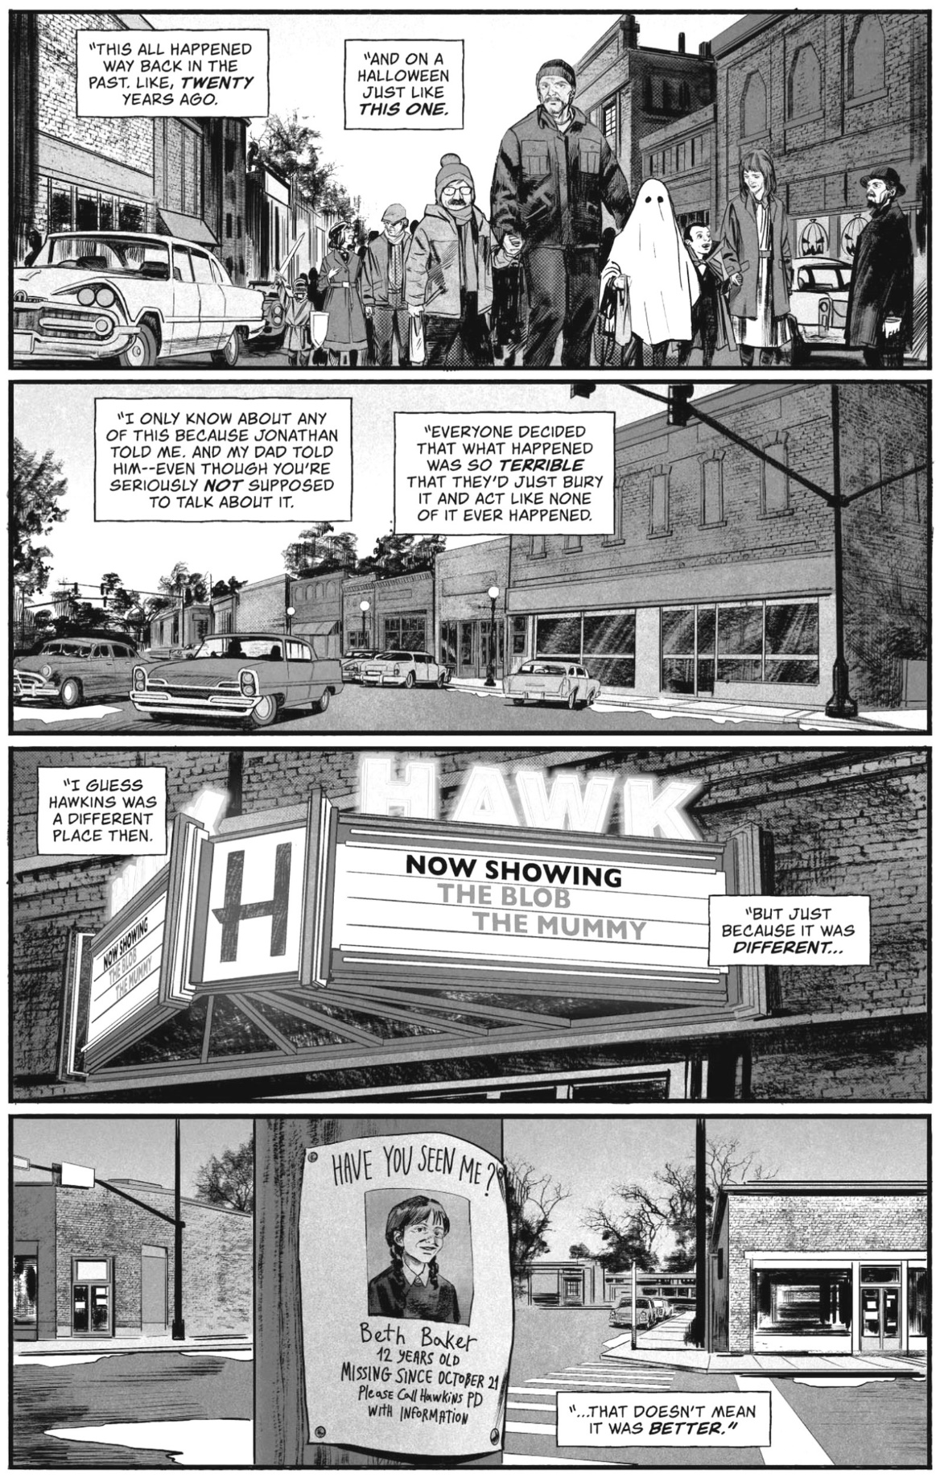

**End of Section One  
  
  
2021 WAEP Year 12 ATAR Sem 1 Comprehending**

Question 1 (10 marks)

Explain how language and stylistic choices shape a sense of voice in Text 1.

**Text 1**

An extract from The Weekend Australian article: *Thredbo, NSW:* *It’s all downhill from here*, by Ross Bilton.

The plan was this: a trip with my son, a boys’ weekend of sorts, to the mountain-biking mecca of Thredbo in NSW’s Snowy Mountains. The lad is 11 years old, a determined little nugget with a new-found passion for trail riding. And me? I’ve just turned 50 and feel every bit of it; but I got a nice hardtail bike for my birthday (a Trek Roscoe 8, since you ask) and what better place to christen it than Australia’s self-proclaimed home of alpine riding? Despite that word “alpine”, I wasn’t worried about gruelling uphills, because there aren’t any. The ski chairlifts in Thredbo run in summer, too, and are fitted with bike racks; you just jump on and sail serenely over the snow gums, over flowering mountainsides alive with birdsong, ascending almost 600m above the valley floor – then choose your own adventure on the network of “gravity trails”, graded for difficulty like ski runs, that snake back to town. So no, I wasn’t worried about gruelling uphills. What I was worried about, was biting off more than we could chew: was the lad too young for this sort of caper? Come to think of it, was I too old?

We arrive at the chairlifts for the exact start of the season: 9.00 am on Saturday, November 21. So, too, has a small army of mountain bikers. They look serious – nearly all have dual-suspension downhill bikes; some appear to be wearing body armour – but the mood is chomping-at-the-bit friendly. The lad and I take the Gunbarrel Express chairlift, which deposits us at the top of a beginners’ trail named Easy Street. Even this is a little intimidating at first, with rocky sections and “berms” (banked corners) to contend with. But after a few clumsy mistakes we begin to find our feet, negotiating tricky sections and whizzing down rolling straights, whooping with delight.

By lunch on Sunday, we’ve done most of Thredbo’s 34km network of trails, bar the black-diamond Cannonball Downhill (strictly for experts or nut jobs) and a couple of the cross-country routes around town. The lad and I high-five: mission accomplished, and we’ve had heaps of fun. Yes, we’ve been slow, but that’s OK, there are plenty of places on the trails to pull over and let other riders pass. And the experience has gifted me one of those profound parental moments. Following the lad, my lad, down the Kosciuszko Flow Trail’s series of switchback turns on the Sunday morning, watching him swoop fast round those steep berms, fearless and joyful, having the time of his life, with his old man right behind him. Reader, my 50-year-old heart felt fit to burst with pride.

Question 2 (10 marks)

Compare how Text 1 and Text 2 represent mountain biking for different audiences.

**Text 2**

A copy of the cover of *Britain Mountain Biking UK* magazine (2011).



**WAEP 2023 Sem 1 Markers’ Guide**

The focus in this section should be on the candidate’s comprehension of the examination texts and application of analytical skills. Higher marks should be given to candidates who can respond clearly to the question, provide insightful comments about texts, sustain a point of view and use textual evidence to support a point in a concise fashion.

Question 1 (15 marks)

Discuss how conventions and language features shape genre and response to Text 1.

**Text 1**: An extract from the novel *The Cane* by Australian author Maryrose Cuskelly (2022).

|  |  |
| --- | --- |
| **Suggested mark allocation for Question 1** | **Marks** |
| **Possible genre**   * Crime. * Mystery. * Horror. * Gothic. | **0 – 1** |
| **Conventions**   * The setting of the small town of Quala. * Plot elements – a missing girl, a small town on alert, hidden danger. * Characterisation of parents, the school children. * Point of view (third person omniscient) of people and events. * Representation of mysterious happenings, rumours. * Themes (ideas) a missing girl, protective parents, unexplained events, the disruption of everyday life, unsolved mysteries. | **0 – 4** |
| **Language features**   * Description and imagery. * Figurative language e.g. simile. * Repetition. * Tone. * Punctuation for effect. * Variation of syntax. * Rhetorical questions. * Colloquial language. * Direct speech. * Alliteration. | **0 – 4** |
| **Response is shaped by**   * Rising tensions and suspense. * Selection of details, imagery and description. * Word choice eg 'monster'. * The exaggerated concerns of the parents. * The suggestion that a violent crime has been committed. * Unsettling references to past events. * The mood of the narrative extract. | **0 – 4** |
| **Expression**   * The extent to which the candidate expresses their responses clearly and concisely and integrates examples and/or brief quotes to support their response. | **0 – 2** |
| **Total** | **15** |

Question 2 (15 marks)

Not

**Text 2**: An extract from the comic *Stranger Things* by Dark Horse comics (2022).

|  |  |
| --- | --- |
| **Suggested mark allocation for Question 2** | **Marks** |
| How Text 2 constructs similar themes and mood.  **Narrative Conventions**   * Setting. * Plot elements. * Characterisation of people (costuming, names). * Point of view. | **0 – 3** |
| **Visual techniques**   * Panels that draw attention to the town setting of people and events. * Graphics that show ordinary people, the local cinema, a missing person. * Fonts that are capitalised or in bold. * Light and dark for emphasis. * Details that convey a feeling of the supernatural, a crime or evil forces. * Juxtaposition between fiction (the movie) and a disappearance. * Contrasts, emphasis, balance. | **0 – 3** |
| **Written techniques.**   * Narrative voice, speech, storytelling. * Language choices. * Repetition, tone. * Punctuation for effect. * Foreshadowing. * The representation of people affected by what happened. | **0 – 3** |
| **Similar themes**   * The disappearance of a young girl. * A small town unsettled by the possibility of a horrible crime. * The idea that no one is safe, especially children. * Mystery, horror, crime, unseen forces of evil. | **0 – 2** |
| **Mediums and mood**  Text 1 is a novel and Text 2 is a comic. Both texts convey a sense of dread and anxiety through past events, speculation, and rumours. The atmosphere in both is tense. There is a mood of suspense, of fearfulness, of a small community disrupted by disturbing events. | **0 – 2** |
| **Expression**   * The extent to which the candidate expresses their responses clearly and concisely and integrates examples and/or brief quotes to support their response. | **0 – 2** |
| **Total** | **15** |

**WAEP 2023 Sem 1 Markers’ Guide**

The focus in this section should be on the candidate’s comprehension of the examination texts and application of analytical skills. Higher marks should be given to candidates who can respond clearly to the question, provide insightful comments about texts, sustain a point of view and use textual evidence to support a point.

Question 1 (10 marks)

Explain how language and stylistic choices shape a sense of voice in Text 1.

**Text 1**: Article extract *‘Thredbo, NSW: it’s all downhill from here’* by Ross Bilton.

|  |  |
| --- | --- |
| **Suggested mark allocation for Question 1** | **Marks** |
| **Voice**   * wry, self-deprecating * light-hearted * conversational * casual * reflective * colloquial | **0 – 4** |
| The quality and number of points made in relation to the question.  **Stylistic Choices**   * First person point of view to directly engage with readers * Anecdotes that reveal his experiences and relationship with his son to readers * Juxtaposition to show generational age gaps * Directly addressing the reader and sharing his emotions, thoughts, insecurities * Structural choice of form as an Australian magazine article/blog * Inclusion of details such as mountain biking terminology, the route taken, facts about bikes, bikers and biking * A contemporary Australian context that relates to that audience. | **0 – 4** |
| **Language choices**   * A conversational, confiding tone that engages readers * Light-hearted tone * The use of facts, numbers and terminology to add interest and credibility * Colloquial language understood by Australian readers * Emotive and inclusive language that conveys feelings and attitudes * Descriptive language and imagery * Punctuation for effect, variation of syntax, parenthesis, irony (Easy Street) * Repetition, rhetorical questions, word choice, alliteration * Figures of speech such as metaphor, analogy, imagery * Dry/ wry humour that creates empathy and rapport. * Play on words - title | **0 – 4** |
| **Expression**  The extent to which the candidate expresses their responses clearly and concisely and integrates examples and/or brief quotes to support their response. | **0 – 3** |
| **Total** | **10** |

Question 2 (10 marks)

Compare how Text 1 and Text 2 represent mountain biking for different audiences.

**Text 2**: A copy of the cover of *Britain Mountain Biking UK* magazine (2011).

|  |  |
| --- | --- |
| **Description** | **Marks** |
| The quality and number of points made in relation to the question.  **Text 1**   * The writer represents mountain biking for an Australian public who read The Weekend Australian magazine. * Mountain biking is represented as an opportunity for the writer to bond with his young son and this is emphasised for readers. * The writer is new to the sport and chooses an easy trail to begin with, along the way he and his son learn terminology and tips that are shared with readers. * The emphasis is on fun and connecting with nature rather than hardcore competitive biking, this relates to the relaxed context of a weekend magazine. * To engage his audience the writer uses a conversational style that incorporates anecdote, colloquial language, first person viewpoint, descriptive language and imagery, rhetorical question, a friendly, confiding tone, humour. * He invites identification with his middle-aged readers in his acknowledgement of his age, fitness level and being a parent new to the sport. * The representation of mountain biking relies on the reader’s imagination, identification, curiosity and sense of humour. | **0 – 4** |
| **Text 2**   * The magazine is aimed at experienced mountain biking enthusiasts in the UK who are familiar with terminology. * Visual and written elements are combined to represent the challenge of mountain biking as a sport. Visual techniques include arrangement and layout, the foregrounding of a hardcore biker in action, wearing protective gear, an outdoor rugged terrain setting; free maps to encourage sales; language features that inform and address concerns: punctuation for effect, alliteration, emotive, colloquial language, terminology. * Like Text 1, there is an emphasis on outdoors adventure however the image targets individual experience, independence and skills rather than family recreation. * There is a greater emphasis on information about bikes, protective gear and skills development. * Both texts address the risk of danger, but Text 2 encourages bikers to test their limits on more advanced and challenging trails. * Both texts encourage their audiences to try mountain biking for different reasons. | **0 – 4** |
| **Expression**  The extent to which the candidate expresses their responses clearly and concisely and integrates examples and/or brief quotes to support their response. | **0 – 2** |
| **Total** | **10** |